**(Insert logo if desired)**

Emergency Quick Guide

*Last modified MM_DD_YYYY*

Church Name

Church Address

**Introduction**

This guide is a user-friendly summary of the Emergency Operations Plan on file in the church office. It explains what church members can and should do in response to various emergency situations. Trained Emergency Response Team members will provide direction and assistance, but an educated congregation is a safer congregation. Be sure to check back periodically as a refresher!

The emergencies are grouped by general response and color-coded as follows:

**When do we evacuate?**

* Fire (p. 3)
* Active Threat (Shooter, p.4)

**Where do we go?**

* **(Insert location)** – children & parents
* **(Insert location)** – those with limited mobility
* **(Insert location)** – all others

**When do we stay put?**

* Severe Thunderstorm or Tornado* (p. 5)
* Winter Storm (p. 5)
* Medical Emergency (p. 5)
* Lift Failure (p. 6)
* Earthquake (p. 7-8)
* Pandemic (p. 8)
* Hazardous Materials* (p. 9)
* Protester/Disrupter (p. 9)

**\*Where do we take shelter?**

* **(Insert location)** – for use by the nursery staff and children
* **(Insert location)** – both restrooms can be used to shelter adults
* **(Insert location)** – use for adults, saving space for anyone with limited mobility who will be brought downstairs last
* **(Insert location)** – use for adults and older children who have the ability to crawl under tables

**Additional Resources**

For more information about creating an emergency plan for your home or workplace, visit [www.ready.gov](http://www.ready.gov)

You can also learn more by enrolling in a free disaster preparedness course through your local CERT (Community Emergency Response Team).

**Fire**

**Indicator: Fire alarm – sound and flashing lights**

**Goal: Get everyone out of the building quickly and safely**

* Evacuate the building via the nearest safe exit (test interior doors for heat before opening)
* Follow direction of Emergency Response Team members
* Proceed to the gathering points (playground, driveway, cemetery)
* Wait for further instructions – please do not leave until released

**If there is smoke:** Cover your mouth & nose and stay low; crawl if necessary

**If someone’s clothing should ignite:** Stop, drop & roll. Fireproof blankets are also located under the pulpit and under the pew in the rear of the sanctuary.

**If you are trained AND the fire is smaller than a wastebasket**, you may attempt to use a fire extinguisher (test after pulling the pin). Remember to aim at the base of the fire, not the flames:

PASS - Pull, Aim, Squeeze, Sweep

**Active Threat (Shooter)**

**Indicator: Gunshots or yelling**

**Goal: Get away from the shooter as quickly as possible**

You will have very little time to react in this situation. You will need to decide if you can/will:

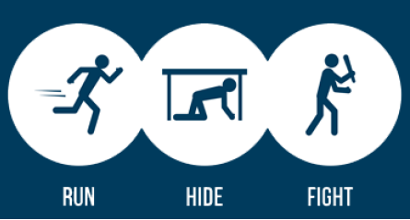

|  |  |  |
| --- | --- | --- |
| * Leave your belongings & exit immediately * Encourage others to follow * Move far away & warn others * Call 911 when you are safe | * If you can’t exit safely, find a place to hide * Act quickly & quietly * Secure your hiding place – turn off lights, close & block door, take cover * Silence cell phones * Do your best to remain quiet & calm | * Last resort * Fight as a group, improvise weapons and work to disarm the shooter * Make yourself a difficult target – throw things to distract the shooter, constantly move & yell until you have the opportunity to attack |

When law enforcement arrives their first priority is to stop the shooter; they cannot stop to help the injured. Remember:

* Do not try to touch them – they will be looking for a threat so put your hands up, spread your fingers, show them your palms and stay still
* If you have subdued the shooter and taken control of the weapon or have obtained a firearm, do not hold it when police enter – as soon as possible place it in a secure location out of sight

We encourage everyone to watch this 6 minute video to learn what actions to take in the event the unthinkable should happen: [**Run Hide Fight**](https://youtu.be/5VcSwejU2D0)

**Severe Thunderstorm or Tornado**

**Indicator: Warning on weather radio (insert location) or cell phones**

**Goal: Get everyone to the ground floor and away/sheltered from the windows**

* Proceed downstairs to the appropriate sheltering location (under stairs, restrooms, coat rack area, under tables along west wall
* Follow direction of Emergency Response Team members who will be monitoring the weather radio to determine when the threat has passed
* Wait for further instructions – please do not leave until released

**Winter Storm**

**Indicator: Warning on weather radio (insert location) or cell phones**

**Goal: Minimize risk of travel in adverse conditions, falls, hypothermia or overexertion**

* Stay indoors until the main threat has passed – consider attending services virtually
* If a snow storm hits while we are at the church, Emergency Response Team members will be monitoring the weather radio to determine when it is safe to leave and will assist in shoveling, salting and clearing off vehicles
* Observe the usual precautions when walking, shoveling or driving

**Medical Emergency**

**Indicator: Abnormal appearance such as skin color changes, heavy breathing, excessive sweating, or abnormal behavior such as clutching a body part in pain, pained facial expression, reported numbness or tingling, illogical responses to questions or unresponsiveness**

**Goal: Help stabilize the person until Emergency Medical Services (ambulance) arrive**

Qualified Emergency Response Team members and/or certified medical professionals (if present) will take the lead in this situation. What YOU can do:

* If you see something or someone looks or acts in an unusual way, say something! Alert an Emergency Response Team member, usher or greeter right away
* Stay calm & follow directions
* Help make the person comfortable until trained personnel take over – do NOT move them
* Help maintain space – our church family naturally wants to help, but the most important thing is to allow space for trained personnel to work
* If you witnessed what happened, remain to provide pertinent information about the incident

**Lift Failure**

**Indicator: Phone call or knocking from inside**

**Goal: Free anyone that might be stuck inside**

In case of emergency, the call button inside the elevator will activate 911

1. **If the lift is on the ground or sanctuary level, the door can be manually opened from the outside.** Remove the key from the upper corner of the door, insert the long end of the key into the hole to the right of the door handle and turn the key clockwise. This will open the door.



1. **If the lift is between floor levels, lower to the ground floor manually:**
   1. Turn off the main power at the control box in the closet by turning counter-clockwise
   2. Turn the red “emergency down” knob clockwise and hold until the lift lowers completely
   3. Follow step 1 above to open the door

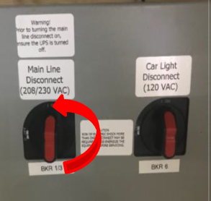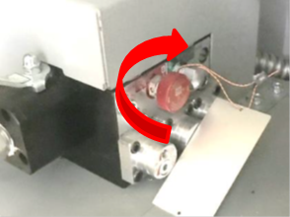



b

a

**Earthquake**

**Indicator: Tremors or shaking but often none, earthquakes can happen without warning**

**Goal: Protect yourself right away** *(Source: https://www.ready.gov/earthquakes)*

* If you are outdoors, stay outdoors away from buildings
* Do not get in a doorway
* Do not run outside

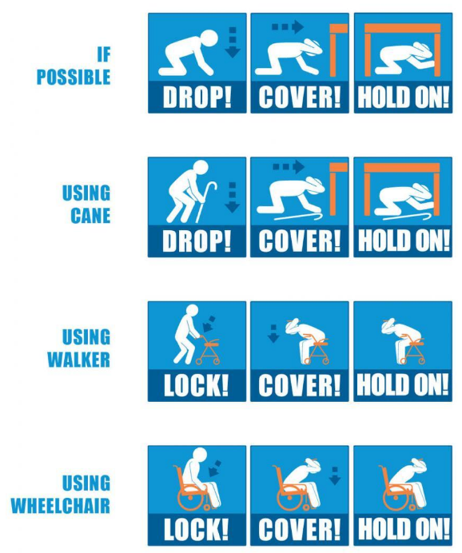

**Drop:** Drop wherever you are on to your hands and knees. If you’re using a wheelchair or walker with a seat, make sure your wheels are locked and remain seated until the shaking stops.

**Cover:** Cover your head and neck with your arms. If a sturdy table or desk is nearby, crawl underneath it for shelter. If no shelter is nearby, crawl next to an interior wall (away from windows). Crawl only if you can reach better cover without going through an area with more debris. Stay on your knees or bent over to protect vital organs.

**Hold on:** If you are under a table or desk, hold on with one hand and be ready to move with it if it moves. If you can’t find a table or desk, cover your head and neck with both arms and hands. If seated and unable to drop to the floor, bend forward, cover your head with your arms, and hold on to your neck with both hands.

After the shaking stops please wait for further instructions – please do not leave until released.

**Pandemic**

**Indicator: News, multiple people falling ill**

**Goal: Maintain our church family’s health & safety**

Depending on the situation and CDC guidelines the Pastor, Trustees, Deacons and Emergency Planning Committee (EPC) may determine that in-person activities must be suspended or altered. What you can do to help prevent the spread:

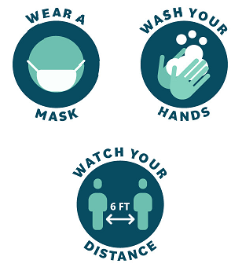

* Follow disinfecting & sanitizing guidelines
* Consider getting vaccinated as soon as a vaccine is made available
* Assist with contact tracing if requested

**Hazardous Materials**

**Indicator: Traffic incident near the church or news alert (train or plane crash or other incident)**

**Goal: Avoid exposure**

Depending on the type of incident, we might be required to shelter in place (see p. 2) but not necessarily take cover, until cleanup is completed.

* Keep all doors & windows closed
* Prevent outside air from entering the building (check for & seal drafts or leaks)

If instructed by first responders, evacuate the building. Keep in mind that our normal evacuation gathering points may not be safe in this situation. We should move:

* UPHILL to avoid liquid contaminants
* UPWIND to avoid airborne contaminants

In either case we should wait for further instructions – please do not leave until released.

**Protester/Disrupter**

**Indicator: Visitor with or without signage using a loud voice or aggressive gestures**

**Goal: Get the protester to leave peacefully**

The Pastor will inform the congregation of the situation as soon as possible. If anyone is uncomfortable with the presence of a protester they should feel empowered to avoid or remove themselves from the situation. Church members are under no obligation to keep themselves in a situation where they feel their (or their family's) emotional, spiritual, or physical well-being are at risk.

Church leaders will position themselves in the parking lot to escort church members into the building if needed. For those that choose to remain, the most important steps are:

* **DO NOT engage with or respond to the protester**
* **Remain calm**

The Pastor will take the lead in this situation and direct trained Emergency Response Team members or leadership to assist as follows:

* Call or specifically ask an individual to call 911
* Send 2 persons to stand near the nursery
* Ask the protester to cease their disruption and leave
* If they do not leave, then ask accompanist to begin playing hymn #1 and ask everyone to sing