HOUSE of WORSHIP DISASTER PLANNING TOOL

A faith leader’s profile for planning, with key questions and links for
Houses of Worship (HoW)
November 2022

HOUSE of WORSHIP (HoW) DISASTER PLANNING TOOL
Module 1- Leadership Roles and Responsibilities
HoW Leadership Roles and Responsibilities 2
Moderator/ President 3
Faith Leaders 4
Council or Governing Body 5
Deacons/Elders 5
Buildings and Grounds/Facilities Committee 6
Treasurer and Finance Committee 6
Education/Preschool/Youth Program 7
Outreach or Mission Committee 8
HoW Members and Friends 8

Module 2- The Community

Preparing for Disaster Response and Recovery 10
- What to Do Today – ‘Blue Sky Days’ 11
- Willing to Respond-Volunteer Resources 11
- Preparation So That You Can Serve Others 12
- Making Connections: Before, During and After 12
- Consider Financial Donations 13

Module 3- Preparation So You Can Serve Others
- Preparing to care for your HoW community in the event of disaster 14
- Individual Disaster Response Needs 15

Appendix and Links 18

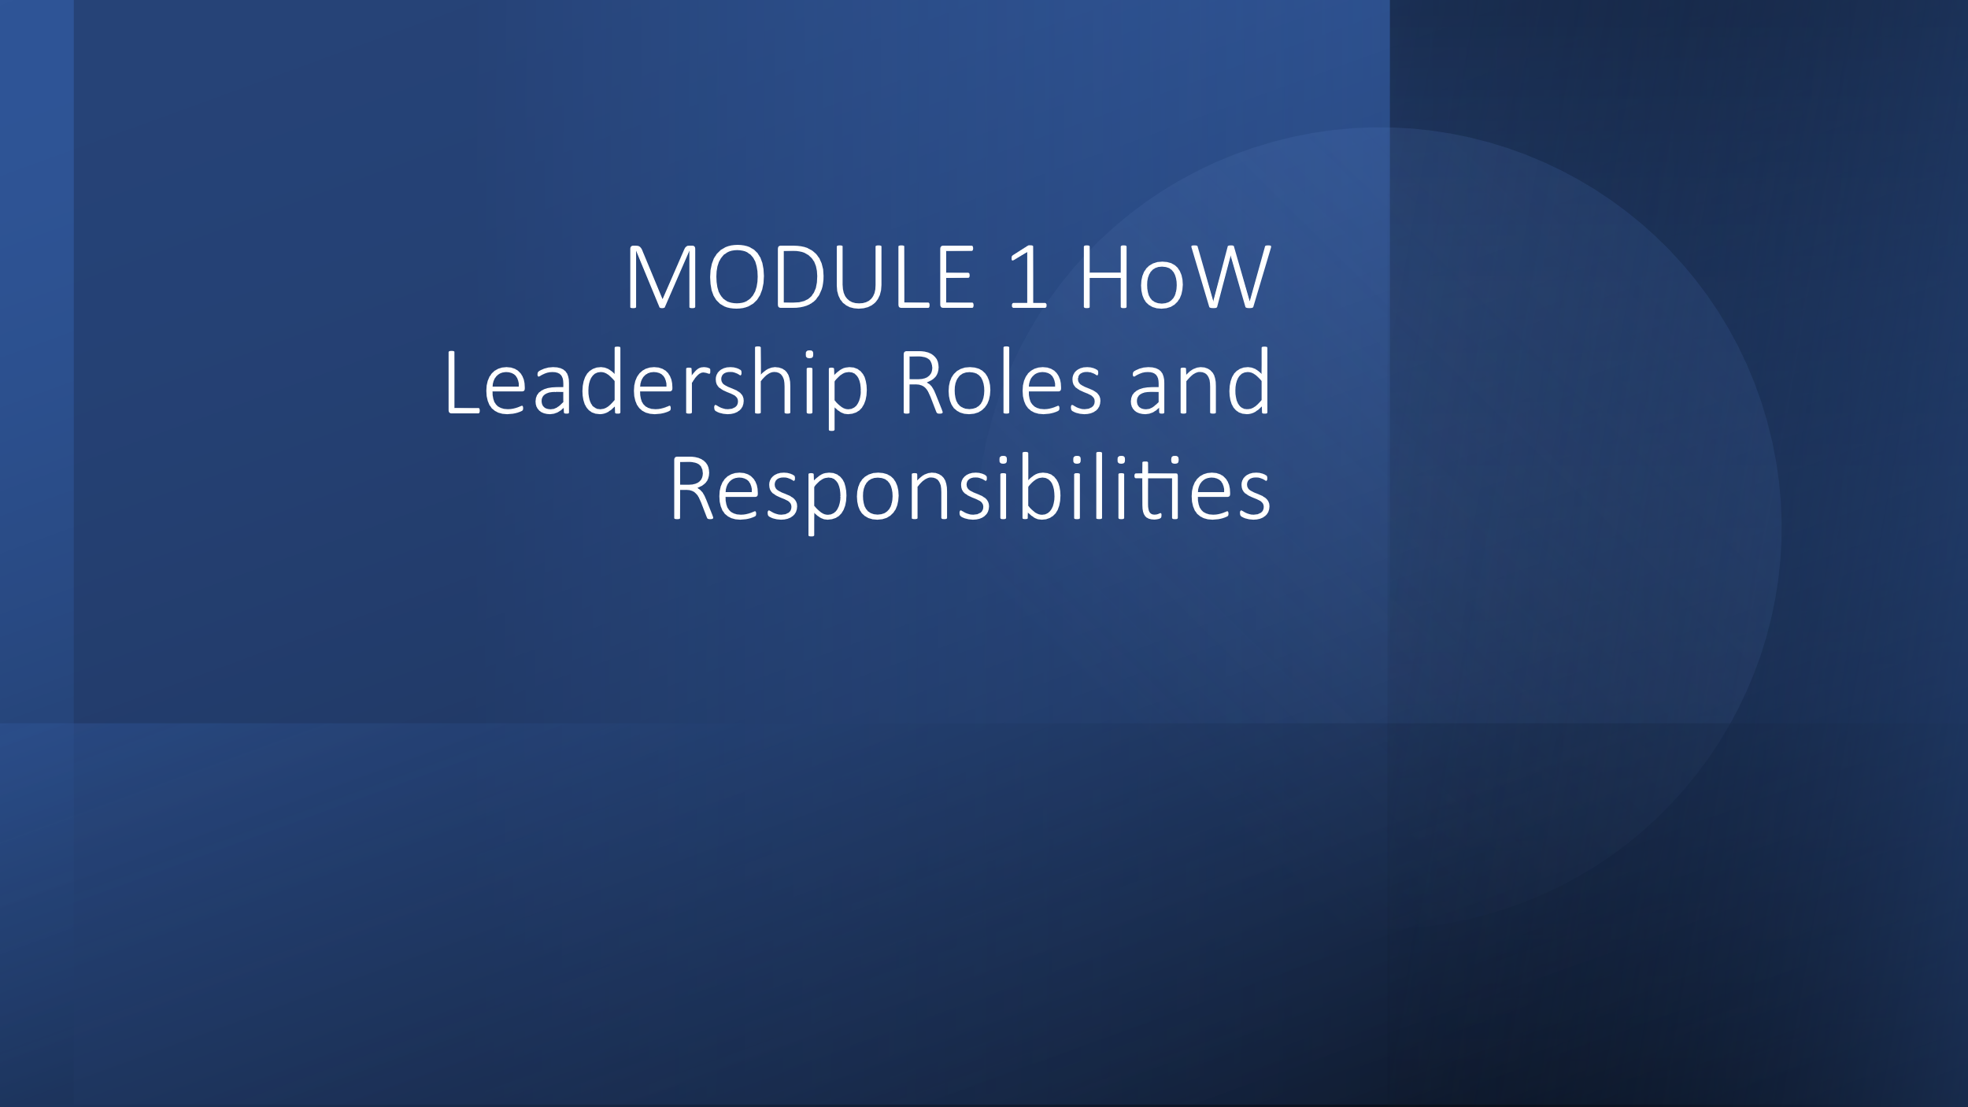

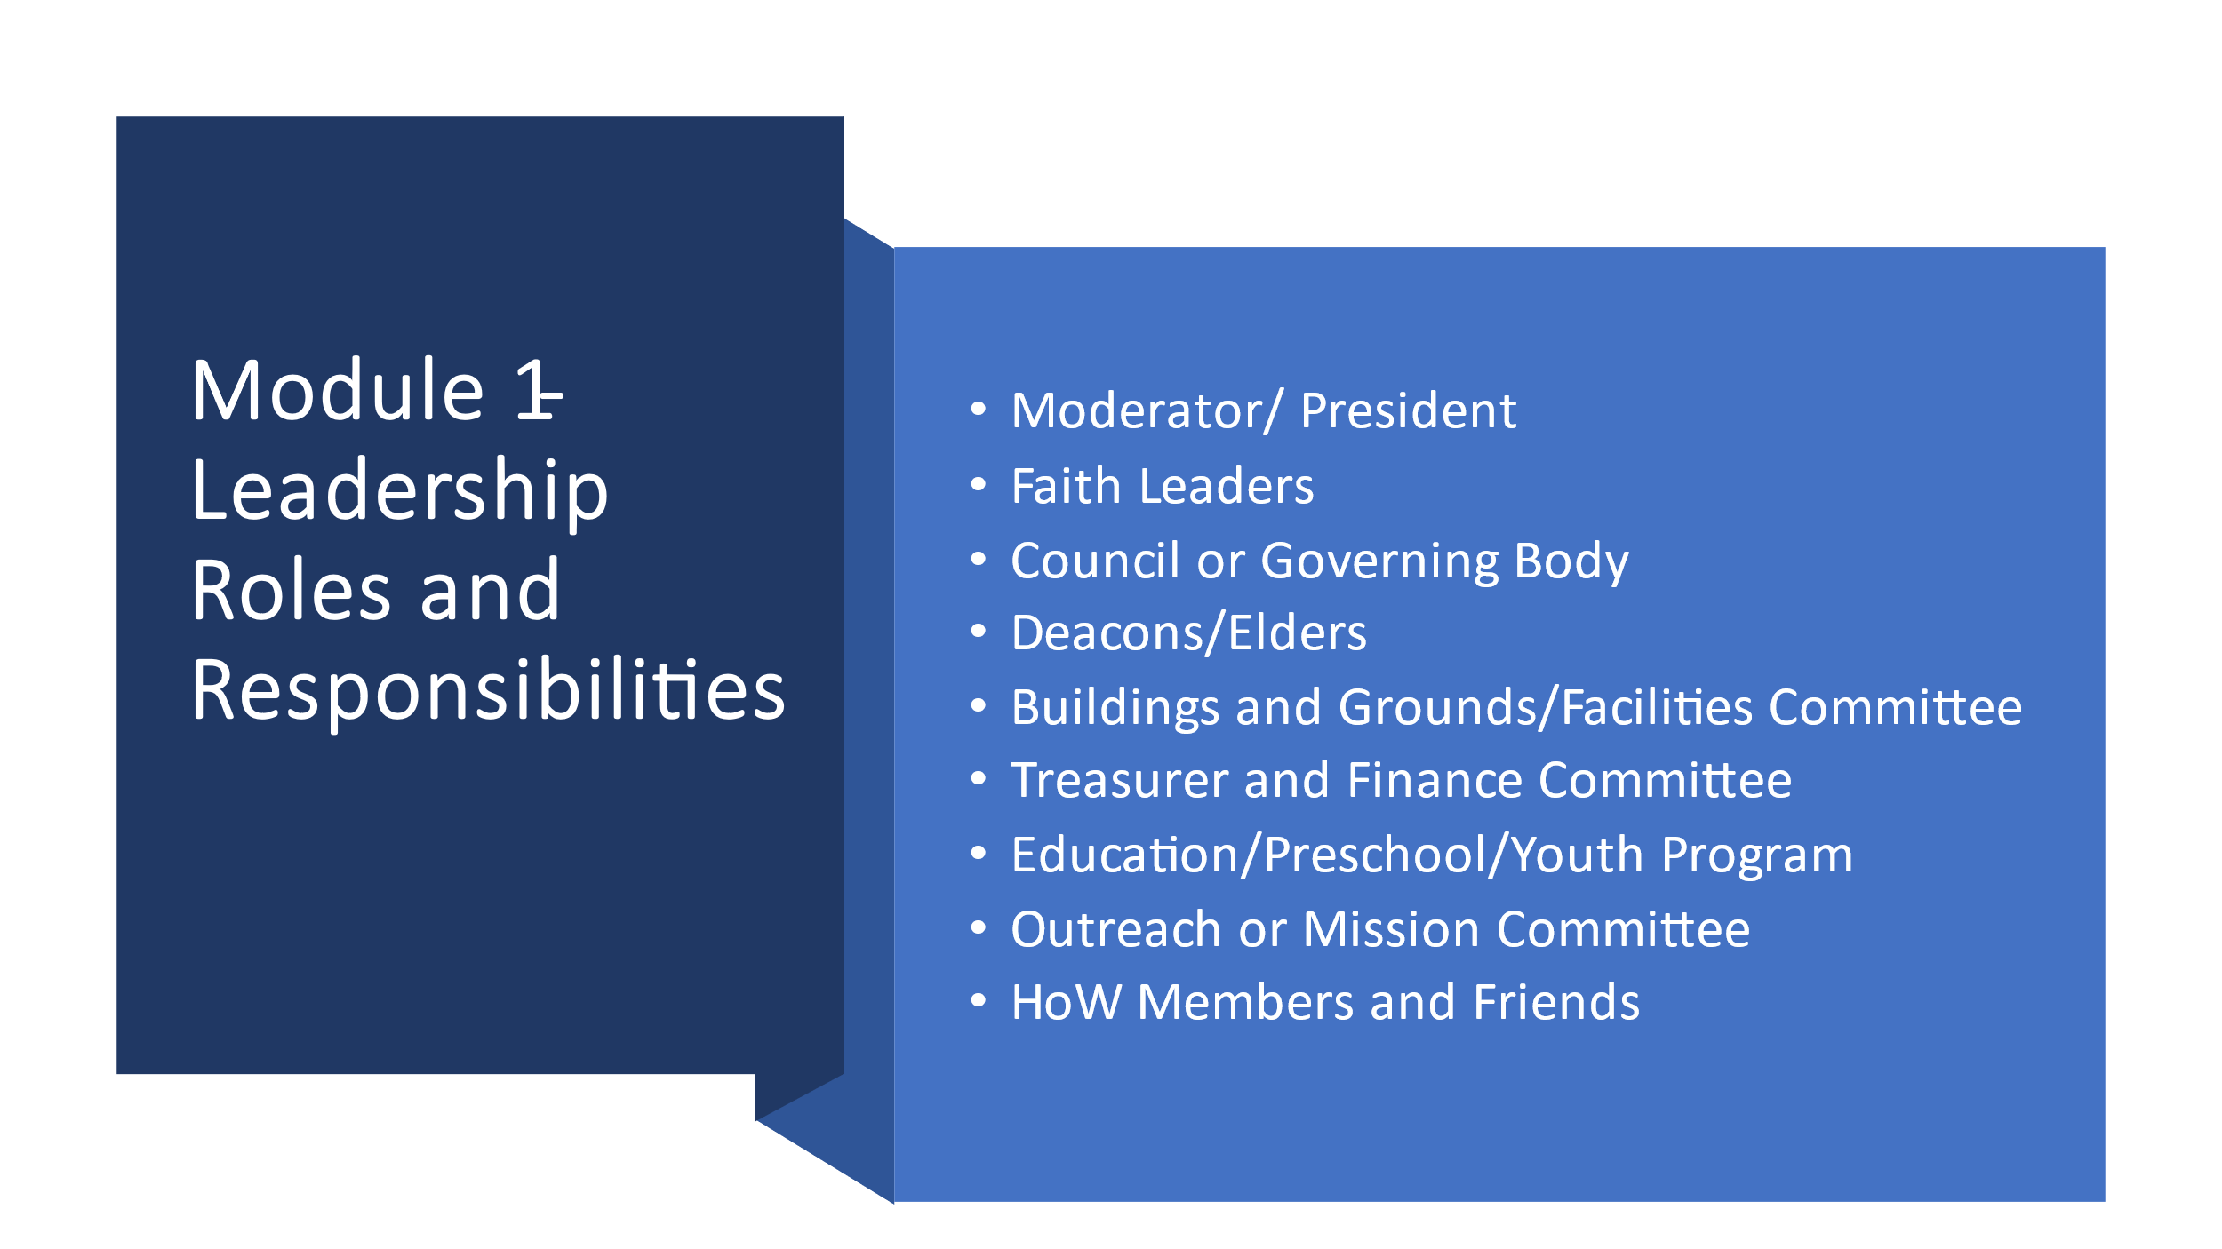

HoW Leadership Roles and Responsibilities
Every committee and HoW leader should have an identified role in times of disaster. Your faith leader, council, board, consistory, and such leads the disaster response and recovery for your HoW. Below are some basic areas to explore with your leadership in preparation for disasters.
  - Moderator, President
In your local HoW do you have a disaster resource team or coordinator (and backup)?
Have you charged them with organizing disaster preparedness for the HoW?
Suggestions for your HoW planning:

Seasonal Warnings- It's important to encourage your HoW members to be prepared if a seasonal disaster befalls your area. Every season has its issues, and you need to be aware of the dangers that may arise.

- In the event of a local disaster that doesn't affect your building, in what way is your HoW able to respond? Can you provide medical personnel, supplies, canned goods (food pantry), clothing and household goods (thrift store), sump pumps, generators, chain saws or people who know how to use them?

- Every community/ county, parish, borough has an Emergency Manager (EM). The disaster contacts for your HoW should know them in advance. This is often the fire chief or the police chief. It's important that the HoW contact the EM to learn the HoW’s role in the event of an emergency. Is your HoW in your town's emergency plan? Does your HoW have a protocol for a disaster response?
See Emergency-Preparedness-Planning-Steward-Summer-2020.pdf (insuranceboard.org)

- Do you have a list of skilled people (carpenters, electricians, nurses, medical staff, plumbers, childcare providers, etc.) who could be called upon should their skills be needed? Do you have access to four-wheel drive vehicles to check on home bound members or shut-ins in the event of snowstorms, or boats in case of flooding?

- You should be aware if your town has a CERT (Community Emergency Response Training) program. Who is the contact person? CERT volunteers respond in the event of a disaster, and you can also contact them for disaster preparedness help, if uncertain please contact your local emergency manager.
See www.fema.gov/community-emergency-response-teams

- Disaster response work is a specialized field. Do any of your congregation members have experience in disaster response work? Some may be able to share experiences with you so that as leaders you will have a deeper understanding. Some examples of these people may be medical professionals, first responders with critical incident training, chaplains, long-term recovery professionals (counselors, social workers), people experienced with mission trips. Does your faith leader have disaster training? Speakers may be available from your National or Regional staff such as a Conference Disaster Coordinator.

- Are you aware of the ways your Regional or National staff can support you in the event of a disaster in your HoW or community? Have you seen a copy of your faith group’s HoW Disaster Plan?

  - Faith Leaders
- Have you had any disaster training in the past 5 years? (Information on emotional, physical, and spiritual resources available and important to aid your congregation.) Many Conferences are encouraging and provide training for pastors. Contact your Conference Disaster Coordinator (CDC) for more information.

- Consider exploring stress management training. The American Red Cross, The Salvation Army and often local mental health centers offer online and/or local training on suicide and other mental health training courses. Psychological first aide courses may also be available online. If you would like self-care courses, you can also be in touch with your CDC or Disaster Minister.

- Are you aware of the concept of caregiver fatigue or compassion fatigue (also called secondary traumatization?) It is very important to understand the role of stress on a pastor in times of crises. If you are not taking care of yourself, you will not be able to take care of others. See compassion fatigue Self-Test for Helpers at Microsoft Word - Compassion Fatigue - Tools.doc (community-networks.ca)
If you score high on compassion fatigue, do you have a trauma informed colleague or seek a trauma informed care therapist.

- Have you done anything to prepare your HoW for a disaster approaching or happening in your community? For some pastors, this is a new concept. Some HOW and community members will look to you for help and support. You can be a healing force in the community by being prepared. You can mitigate the impact of a disaster on children and families through education. You can minimize the impact of disasters on buildings by guiding people to preparedness tools and community resources. By having some resources in place for you and your HoW will lessen the impact of a disaster. Your outreach into the community will increase the HoW's pastoral presence in the community, but do not try to do it alone.

- How prepared are you and your HoW to respond to a disaster? This document can be used in a HoW leadership meetings or added to the HoW constitution or charter for accessibility, allowing members of the congregation, your staff, and your committees to organize your disaster role in the community. If you have questions, please contact state or regional HoW coordinating bodies.

- Do you have lists of potential skilled members such as physicians, faith leaders/chaplains, nurses, EMT’s, psychologists, veterinarians, and animal care givers, and other potential first responders (and their contact information) in your HoW who could be mobilized in the event of an emergency at your HoW?

- Are you aware of liturgies, music, other worship aids for use at a times of disaster? When disasters happen, we need to be able to respond to spiritual needs right away. Here's a link to help you find resources of this sort – www.macucc.org/followingadisasterresourcesforpastors.

- Are you aware of your conference and national staff that may be able to support you in the event of a disaster in your HoW or community? Are you also aware of other denominational resources which can be found at the https://willingtorespond.org website among other web sites?

- It is very important to become aware and interactive with other local faith leaders in advance of a disaster. Have you talked with your local faith groups and associations about how you can work together should a disaster happen? Please share this document with them.

- If your HoW is vandalized or experienced an unauthorized entry do you have a protocol for how to respond first on the scene- including calling 911, stumble into it and caring for those affected afterwards.

  - Council or Governing Body
- The Council is the body to encourage, inform and empower the committees and staff to prepare for disasters in advance and offer support and suggestions for ongoing improvement and readiness for implementation of the following programs.
- This body is responsible for the training, and over all response to disaster and recovery for the HoW and its members and community.
- Someone on the Council or designee should serve as the disaster point of contact representing the HoW with the local Emergency Manager.

  - Deacons or Elders
- Contacts - In an emergency, it is important to reach out to your members to make sure they are okay. Do you have a telephone/text tree so that you can rapidly contact all your HoW members if there is an emergency or a disaster in your local community? Have you considered using social media to contact members? Are you set up to send a mass email or text to members and friends of your HoW? If there is no electricity in your community, how will you contact members?

- Do you have emergency contact information for all your congregants? It should include email, text, and telephone contacts, as well as emergency representative information. Do your HoW members carry a printed HoW wallet card asking for your HoW to be called in case that person is taken ill or injured? Information the card would include Name of HoW, Name of Faith Leader, Phone Number, Email Address, HoW Address. It is suggested that you share this card with each member of the HoW for them to add to their emergency go kit.

- Who are the most vulnerable-special needs people in your HoW community? If something were to happen, how would you reach out to them? Do you have a “buddy system” that is identified in advance to build trust and familiarity for individuals to check on those who might need help to prepare, evacuate or be checked on afterwards? Do your lists include the folks who are not HoW members, but who still consider yours their “HoW home”? What about vulnerable people who are not members of any HoW, who are known to your HoW members?

- Do you have lists of physicians, faith leaders/clergy/chaplains, nurses, EMT’s, psychologists, and other potential first responders (and their contact information) in your HoW who could be mobilized in the event of an emergency at your HoW?

- Do you, your ushers, and other HoW officers know who the physicians, nurses and EMT’s are in your congregation, where they are seated during worship, and their location in the building during meetings?

- If someone was to act out in your HoW either during the week or during a service or event, and could become physically dangerous, do you have a protocol in place to deal with this? Do you have a disruptive person’s policy or a behavioral covenant?

- Has your HoW received any active shooter training? Do you have a plan?

  - Buildings and Grounds/ Facilities Committee
- Facilities Use
  - Is your HoW willing to let the building be used in times of disaster? Suggestions for us include warming stations, feeding stations, shelters, pet shelters, wi-fi, water, distribution of emergency supplies, emotional and spiritual care support etc.
  - How are you planning to serve the needs of your congregation or neighbors in times of disaster?
  - Does your HoW have the necessary emergency equipment on site to serve the needs?
  - Do you have a commercial kitchen, and could your kitchen be used to aid the community if called upon in a disaster?
  - Could your HoW be used to house volunteers in the event of a local disaster? Do you have showers?
  - It is recommended that facilities rekey the building every 5 years- to maintain security.

Training and Planning
  - Have you connected with American Red Cross-Emergency Management Agency in your community to inform them of your interest and receive training?
  - Do ushers and HoW officers know the location of evacuation shelters, fire blankets, and extinguishers– especially on High Holy Days?
  - Have your HoW staff/members been trained in running a warming station or a shelter? If yes then, who are the trained leaders, and how can they be contacted?
  - Planning- has the HoW met with both police and fire to walk through the building and provide fire drills, prevention policies and safety measures.

  - Treasurer and Finance Committee
- If your treasurer is not available can your checks still be written by someone else authorized? Are your financial records backed up in the cloud? Is your insurance up to date?

- Are your HoW historical records and artifacts inventoried and catalogued? Copied? Insured? Are the originals kept safe? [NOTE: If your HoW houses colonial era records and/or records of a closed HoW, please consider contacting the Congregational Library’s Hidden Histories Project to have them documented and possibly removed to the library for safe keeping. Records prior to 1800 are often very valuable historical documents for historians and should be protected from damage and loss. Further information on the Hidden Histories Project, in partnership with Yale University, can be found at http://www.congregationallibrary.org/nehh/main ]

- How are your valuables kept safe? Are any stored off-site? Are they adequately protected from fire, hurricanes/tornados, and flooding? Who oversees retrieving and caring for these in case of a disaster?

- After a disaster, is there an ethical/legal protocol to follow if your HoW starts receiving financial gifts to help rebuild or restore your HoW or community? How aware are you of this protocol?

- It is recommended that your committee check your insurance policy annually and make sure the HoW and its contents are covered in the event of an earthquake, flood, hurricane, tornado, or fire? Who does this task?

- Access Insurance Board preparedness, loss control and safety information at. Safety Central - Insurance Board Loss Control Department Step‐by‐step guides to prepare your HoW building for specific events are continuously updated. See https://www.ucc.org/disaster_resources

- Links:
- The Congregational Library has information about managing, storing, and safeguarding HoW records. About Us | Congregational Library & Archives
- Homepage - Insurance Board HOW Property and Liability Insurance
- Along with emergency specific checklists, information pertaining to additional topics surrounding the protection of your congregation and your HoW facilities are available. For additional questions please email losscontrol@insuranceboard.org

  - Education/Formation Committee/Preschool/Youth Program
- Have you practiced drills such as fire, earthquake, tornado, and active shooter in your HoW?

- Have your HoW children/youth and/or members helped others who have experienced disasters – in the community or in the world?

- Have you talked with your parents about how to help children/youth understand weather disasters, damaging fires, and evacuation? Welcome to Ready Kids! | Ready.gov

- Have you ever had your HoW children/youth think about disasters in the news, and talk about how important it is to stay calm should you face a disaster and need to evacuate? How to talk to children about difficult news (apa.org)

- Could your children/youth put together “Go-Kits” and help their families plan for disasters? They are likely to be concerned about their pets, too, if they have them. Pets also will need their own Go-Kits. See https://www.ready.gov/build-a-kit

- Are children/youth in your congregation handed alternatives to lighted candles– e.g., glow sticks, LED candles?

  - Outreach or Mission Committees
- Has your HoW ever been involved in mission trips that conference-disaster ministries are sponsoring or community-based response and recovery efforts?

- Do you know how to support community recovery in your local HoW?

- Do you encourage your members and friends to prepare and have “Go-Kits” in their cars? https://www.ready.gov/build-a-kit

- If for any reason people in your congregation had to evacuate the HoW or their homes, do you, their neighbors, and other family members know where your individual members might go?

- Pets are not always allowed in shelters. (Service animals are allowed in shelters.) If people have pets, what might they do with them? Do not forget to have emergency supplies packed for your pet as well.

- Be aware that several faith-based organizations and Non-Governmental Organizations provide food and bulk distribution in times of disaster, including the local food banks and pantries, the American Red Cross, the Southern Baptists, The Salvation Army, and many other groups. Know who these groups are in your community to assist others.

  - HoW Members and Friends
- If you had to evacuate within 20 minutes, what kinds of things should you bring? How long would it take to get everything together? Are you responsible to pack for others: elderly parents, young children, persons with disabilities etc. What will they need to survive?

- Do you know what a “Go-Kit” is? Do you have them in your cars? Do you have a stay kit for your home with enough food and water for 3 to 10 days depending on the size and scope of the disaster? A Go-Kit consists of food, water, extra clothing, medications, supplies and other necessities sufficient for three days for each person. For further information see https://www.ready.gov/build-a-kit

- If for any reason you had to evacuate, do you know where might you go? Do you have a potential list of multiple locations to stay if you needed to evacuate?

- The ARC has a system called Safe and Well to help connect family members. English - www.redcross.org/safeandwell Spanish - https://safeandwell-es.communityos.org/zf/safe/add. Social media is another way to check in with loved ones. Do your neighbors and other family members know where you might go? How do they reach you if cell towers are out?

- If you have pets, what might you do with them? Pets are not always allowed in shelters, but service animals are permitted by law. Do not forget to have emergency supplies and carts, medicine etc. packed for your pet as well. https://www.ready.gov/build-a-kit

- Does your community have a designated shelter? Are there transportation resources to get people to the shelter if needed (rides, boats, 4-wheel drive vehicles)? To find your local shelter check the ARC Disaster Shelters | Find Shelters | American Red Cross or your local emergency management Https://www.nemaweb.org website.

- Every year people die because they're not prepared for weather and human caused disasters. Check out this Calendar resource from Massachusetts United Church of Christ Conference. http://www.macucc.org/files/files/documentsmissionjustice/preparedness+guide+new.pdf

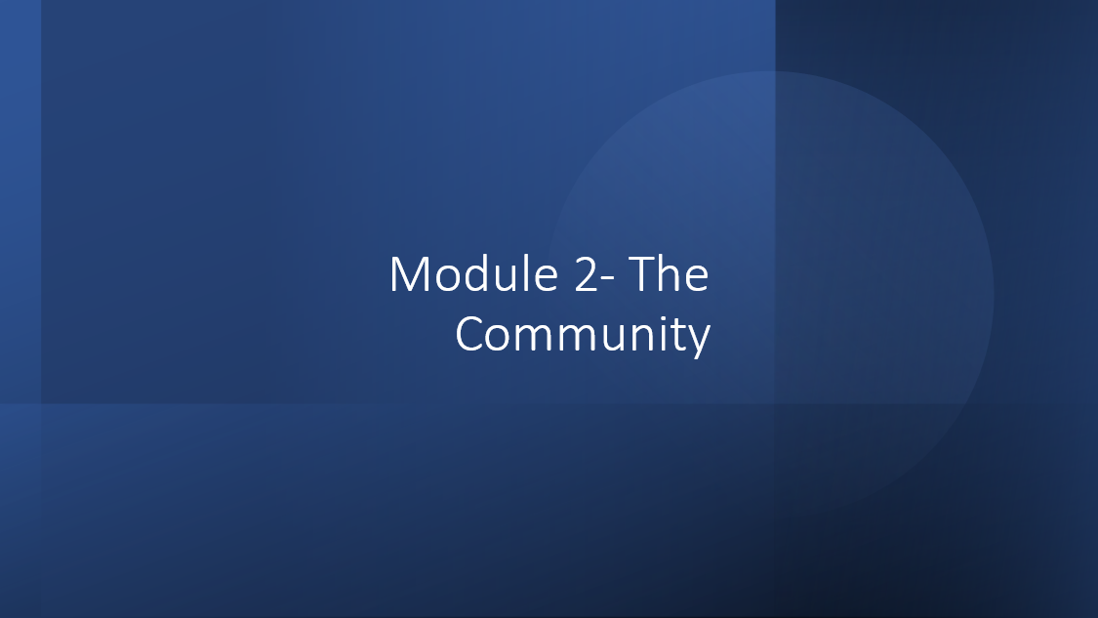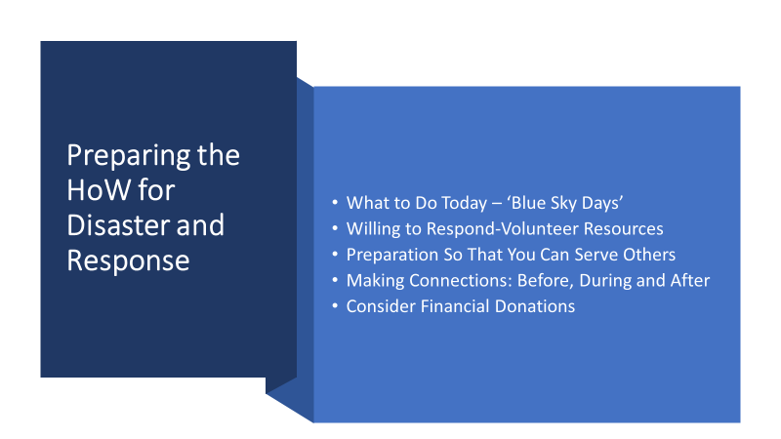

Preparing for Disaster Response and Recovery
  - What to do today – ‘Blue Sky Days’
    - Make an asset list of HoW property. Assess your HoWs accessibility for persons with disabilities to evacuate and shelter. Consider becoming a Disaster WISE Community. United Church of Christ WISE Program Becoming a WISE Congregation Toolkit (mhn-ucc.org)
    - Identify your insurance information and insurance agent to share with Emergency Manager.
    - Identify the location of the HoW’s emergency plan. Share the emergency plan with the local emergency manager.
    - Offer to create an ‘exchange’ with a HoW across town or in the town next to you, storing each other’s hard copy documents in case of emergency. Often during or immediately after a disaster, roads are blocked, power is down, or buildings have been damaged. You need to be able to get this information, even when you cannot physically get to your HoW.
    - Consider compiling a 3‐day supply of sustainable foods and water or using your resources to keep at the HoW to support the locally community and be sure to rotate as needed. For the 3-10 day list of supplies everyone should have. Emergency Supply List (ready.gov)
    - Fill out the House of Worship Contact Information sheet in the Appendix.
    - Be sure to ask community-based groups, such as the Preschool, Boy Scouts, AA, and other worshipping groups who regularly use the facility to have their own disaster plans and share them with your leadership.
    - To serve your community disaster plans should include all Hazards- Tornado, Winter Storm, Hurricane, Earthquake, Wildfire Lightning Strike, Flood, Active Shooter, Tech-Climate Disaster, Cyber Attack, Pandemic-Health emergency, WAR- Civil Unrest, Church Burnings and other emergencies that may happen due to your local conditions.

  - Willing to Respond-Volunteer Resources
            - Is your HoW registered with the Willing to Respond Network if not click here to explore more information. Place LINK
            - Would your HoW be willing/able to mobilize volunteers in an emergency, for response or for recovery to assist at your facility or in the community? Yes No, why not?
            - Estimated number of volunteers that you could mobilize: _____________
            - Does your HoW provide volunteers to assist Police or Fire agencies with ongoing public safety programs? Yes No, why not?
            - The next section helps your HoW estimate the occupations and/or skills of your members who may be called upon to serve the community in times of crisis Do you maintain information regarding the occupation or skills of our members? If you have the following individuals within your HOW, estimate the number below:
______ Medical Doctors
______ Nurses or LVN’s
______ Paramedics/EMTs
______ Psychologists and crisis counselors
______ Individuals trained in CPR/First Aid
______ Retired* public safety personnel (Police Officers, Sheriffs Deputies, fire fighters, military)
______ Other (amateur radio operators, etc.)

  - Preparation So That You Can Serve Others
Get connected to your Conference Disaster Coordinator to learn about the support the Conference and UCC Disaster Ministries can offer when an event occurs. https://www.ucc.org/disaster_us‐disasters_ucc‐disaster‐coordinators

- Get connected to your local Voluntary Organizations Active in Disaster group https://www.nvoad.org/voad‐members/stateterritory‐members / or Community Organizations Active in Disaster group.

- Have your Disaster Planning Team take emergency response training, such as, Community Emergency Response Team (CERT) training. https://www.ready.gov/community‐emergency‐response‐team

- If you want to be eligible to serve as a shelter when a disaster occurs, contact your local American Red Cross chapter https://www.redcross.org/find‐your‐localchapter or The Salvation Army to get certified.

- Make a list of the current ministries your HoW has and how/if they can be mobilized to serve the community in the aftermath of a disaster. Example: Ministry Description Point person. Food pantry Dry and canned goods, milk, and cheese- Michelle Sawyer

  - Making Connections: Before, During and After
- Be in contact with your local American Red Cross chapter to confirm your availability and eligibility as a shelter location.

- Contact members of your HOW ministries that can be mobilized for disaster response and ask them to be on stand‐by.

- Connect with your Conference Disaster Coordinator, local Emergency Management and State and Local Voluntary Organization’s Active in Disaster (NVOAD) and community based Long Term Recovery Groups to learn more information about local needs and coordination efforts.

- Remember the 4 Cs of National Voluntary Organization’s Active in Disaster (NVOAD) in your response: Collaboration, Cooperation, Communication and Coordination! https://www.nvoad.org

  - Consider Financial Donations
- As another way to serve your community is through donating cash. Cash is best. Cash offers provide the most flexibility in obtaining the most-needed resources. Organizations typically prefer cash donations because they allow our members to offer emergency support and longer term grants.

- How donations are collected and for whom matters. Think ahead and plan and do your research. Sometimes there are items that are needed for a specific disaster do your research and help when asked. Donating physical items may create a disaster within a disaster. HoWs often become unwilling warehouses for unusable resources.

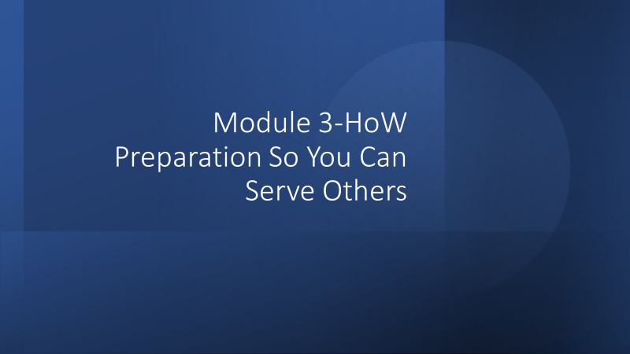

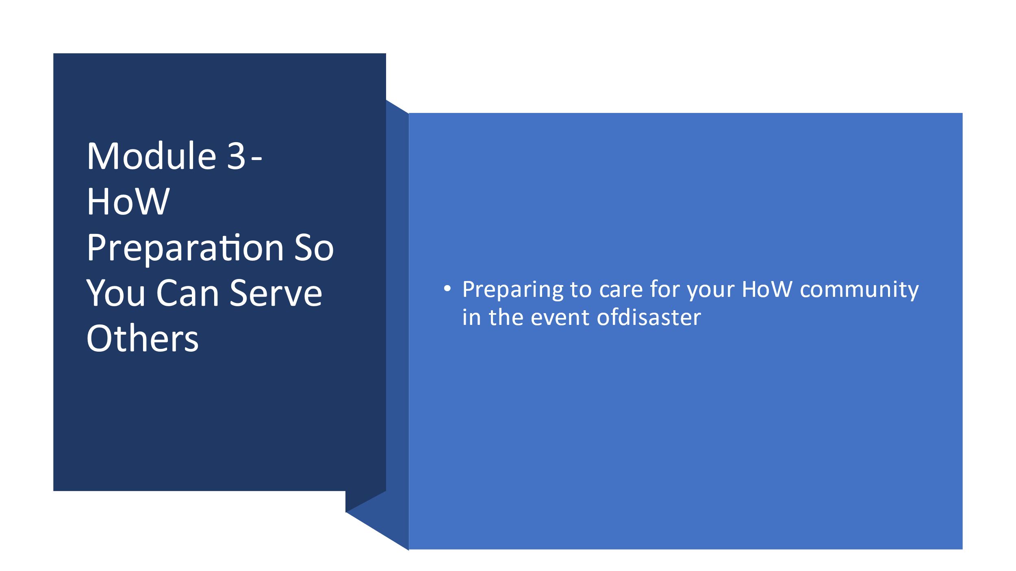

  - Preparing to care for your HoW community in the event of disaster
Your HoW has an opportunity to play an important role in the event of a local disaster in the ways it cares for its people. Does everyone in the HoWs care have safe shelter, water, food, medicine, etc.? Does anyone need transportation? What other needs are there?

Contact List of all Souls on Board
- Contact List of all Souls on Board.
  - Your HoW already has a list of ‘members’ with addresses, phone numbers, email, etc. you have the information you need to reach them.
  - Include in that list your HoW’s “Souls on Board” those people who are not officially members, but participate in HoW activities, ministries, etc.
  - Out-of-town contact for each member or Soul on Board family.
  - Designate individuals with special needs- mobility, medical equipment (oxygen, etc.). Note where living: at home, or in structured settings.
  - Encourage all the HoW pet owners to have a plan for their pets including food, medicines, crates to transport, toys, papers, and other items they may need. Pet Disaster Preparedness & Recovery | American Red Cross or https://www.ready.gov/pets
  - Designate individuals with special skills, such as nurses, doctors, EMTs, electricians, ham radio operators, etc.
  - Multiple Copies of these lists need to be stored safely in multiple locations. The Church Office may be inaccessible.

- Allocate the list to Designated persons. This might be the Elders, or some other identified group. Might be designated Disaster Team.
  - Every Soul on Board would be assigned to a specific individual.
  - In the event of a disrupting event: power outage, flood, tornado, snowstorm, etc. Designated team is to connect with each family on their list; find out if they are safe, where they are, what they might need.

- If you are still using landline phones, post emergency phone numbers and the HoW’s address at each physical phone inside the HoW. Back up information should be considered a part of your disaster planning.
You should have:
- 2 hard copies of your asset list, insurance information, and emergency plan
- 1 digital copy of each that is accessible from outside the HoW’s physical computer (remote access).
- Keep 1 hard copy in a secure location in your HoW and a 2nd copy offsite.
- Information gathered by Disaster Team collected by a designated person. Best Practice if this is NOT the Pastor. It should be a specifically designated individual who knows this is their job in an event. The collected information can then be used to meet the unmet needs of the HOW’s Souls on Board.
  - In a large disaster. Something that would displace a number of people in the area, this information would be helpful to share with the local Emergency Operations Center. Their task will be accounting for any missing persons in the affected area.

- Encourage individual preparation 3-10 day list of supplies. https://www.ready.gov/sites/default/files/documents/files/checklist3.pdf?msclkid=0ed09c74b9e911ec854ee8ad146fb35e

- Immediate Needs What can the HoW facility offer?
  - Food Pantry
  - Space for feeding
  - Emergency shelter space
  - Short-term housing for displaced survivors
  - Housing for a Radio shack (ham radio operations center)
  - Parking lot staging for other disaster responders
  - Submit “Willing to Respond” information for your HOW www.willingtorespond.org

- Donations and Deployment
  - Cash is Best. Physical items collected create a ‘disaster within a disaster due to the burden created to sort, store, and distribute items, many of which will be unhelpful.
  - Collect and send physical items ONLY when specifically asked by an agency on the disaster site.
  - Do NOT self-deploy. If individuals want to offer their help in response, let it be only through a volunteer management group. Self-deployment is almost always more trouble than worth.

- Identify and connect volunteers
  - Red Cross, Salvation Army, Community Response Team (through Emergency Manager)

- Designate and Publish an off-campus meeting site
  - In the event of building evacuation, etc.
  - Regularly publish this location in bulletin, newsletters, etc.

- Contact Agencies
  - Red Cross, Salvation Army, Emergency Management Center, etc. Make these contacts and offers of space before the disaster.

- Plan Before Need
  - Don’t wait until the tornado arrives to create these lists and the structure to make the contacts. Think through the steps now.

- Make sure everyone knows the plan.

- Practice the plan.

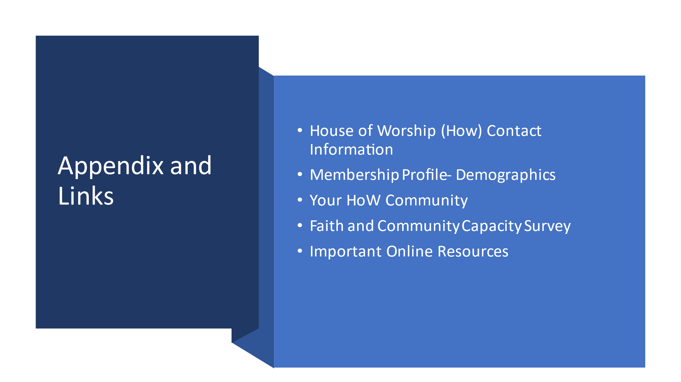

House of Worship (HoW) Contact Information

Date ________________________
HOW Name: ___________________________________________________________________________
HOW Address: _________________________________________________________________________
HOW Phone Number (s: _________________________________________________________________
Name of pastor(s) and contact information__________________________________________________
Name Contact Phone Number_____________________________________________________________
Facebook name, other___________________________________________________________________
Emergency Contact (Name and Phone Number) ______________________________________________
Name and contact info for HOW leadership_________________________________________________
Name Contact Phone Number____________________________________________________________
Facebook name, other __________________________________________________________________
Emergency Contact (Name and Phone Number) ______________________________________________
Name and contact info of the HOW Disaster Coordinator _____________________________________
Name Contact Phone Number ____________________________________________________________
Facebook name, other __________________________________________________________________
Emergency Contact (Name and Phone Number) _____________________________________________
Name and contact info of the Conference Disaster Coordinator ________________________________
Name Contact Phone Number____________________________________________________________
Facebook name, other __________________________________________________________________
Emergency Contact (Name and Phone Number) ______________________________________________
Name of Insurance Company: ____________________________________________________________
Insurance Agent (name, phone, email): _____________________________________________________
Policy number: ________________________________________________________________________
Conference Minister (name, phone, email): _________________________________________________
Associate Conference Minister(s) (name, phone, email): _______________________________________
_____________________________________________________________________________________
Conference Disaster Coordinator (name, phone, email): _______________________________________
City Emergency Manager Name and website: ________________________________________________
County Emergency Manager Name website: _________________________________________________

Membership Profile- Demographics
For consideration of persons who may be disabilities this section is optional
1. Total Number of Members: _________
Number of Participating Members: ______________
Participating Non-members (including children): ______________

2. Number of Participants: Are these figures- Estimated or Actual
A. Ages 1-11: ___________ D. Ages 25-34: ________ G. Ages 55-64: ___________
B. Ages 12-17: __________ E. Ages 35-44: _________H. Ages 65-79: ___________
C. Ages 18-24: __________ F. Ages 45-54_________ I. Above 80+: ___________

3. HOW Family Profile: Are these figures- Estimated
% Single Adults 18-35__________
% Single w/children at home____________
% Single Adults 36 + ___________________
% Married__________________
% Married w/children at home __________________
% Blended Families____________________
% Widowed*______________________
Actual Note: Percentage may add up to more than 100%

Your HoW Community
Describe the ministry area your congregation serves. (i.e., inner city, suburban, small city, rural). Include size of community, and appropriate demographics such as ethnic makeup, average age, projected growth, and household income.

DESCRIPTION OF COMMUNITY
Approximate size of community (check one)
☐ Rural ☐ City (25,001-50,000)
☐ Town (2,500-5,000) ☐ City (50,001-100,000)
☐ City (5,001-10,000) ☐ City (100,000-200,000)
☐ City (10,001-25001) ☐ Large City (200,001 +)

- How has your community changed over the past five years?
- What future changes do you see occurring in your community? Will this enhance or deter your ability to help during a disaster.

- What is your congregation known for in the community?
- What partnerships does your congregation support- including ecumenical, disaster, homeless, etc.?
- Do you have an evacuation route planned out? If so, please attach or describe the route.
- How many fire extinguishers do you have? How often are they check or replaced?
- Does your HOW participate in Steven’s Ministry, Parish Nursing or Wellness and Health Ministry?
- Additional HOW programs such as, offering translation or other support services for non-English speakers? If so, please describe? Using the app on google translate to speak with others.

- Additional HOW Ministries such as, do you offer services to individuals with disabilities or other special needs (listening devises, sign language interpretation, wheelchair assistance, sighted guide for the blind etc. If so, please describe?

- Does the HOW or members have a relationship with a/an animal shelter?

Faith and Community Capacity Survey

*Adapted from WI Office of Justice Assistance 2009 House of Worship Survey
Please respond regarding your organizations physical resources that may be available to serve the community in a disaster, such as buildings, vehicles, equipment, etc.
Do you have a gym, large fellowship hall and/or classroom that would be
available to house people from the community in the event of a disaster? Yes No
If yes, estimate the number of people that you could house? __________
Are your facilities (halls, restrooms, etc.) wheelchair accessible? Yes No
Does your facility have a commercial-type kitchen? Yes No
If yes, estimated number of people you could feed in a crisis? __________
Do you have a food pantry for food distribution to those in need? Yes No
Do you have clothes closet for clothing distribution to those in need? Yes No
Do you have van(s) and/or bus (es) that could be used during a crisis? Yes No
If yes, please describe__________________________________________________________
Are your vehicles wheelchair accessible? Yes No
Do you have licensed drivers for these vehicles? Yes No
Do you have childcare facilities on site? Yes No
Please describe any other equipment or physical resources that you may be able to provide in
the event of a significant local emergency (generators, ham radios, warehouse, etc.)

Important Online Resources

- A- Disaster Preparedness Manual for Churches- https://www.uccfiles.com/pdf/A-Disaster-Preparedness-Manual-for-Churches.pdf
- ARC Shelter Information- https://crcog.org/wp-content/uploads/2017/12/American-Red-Cross-Sheltering-Handbook.pdf
- Clergy Care Good- Bad-www.alban.org/archive/clergy-self-care-strategies-for-good-times-and-bad/
- Clergy Care Strategies-www.google.com/search?q=clergy%20care%20strategies&rct=j
- Disaster Manual- Episcopal Relief www.episcopalrelief.org/uploads/EducationFileModel/105/file/ProvIV-Disaster-Manual.pdf
- Disaster Ministries- http://www.ucc.org/disaster
- Disaster Resources- www.ucc.org/disaster_national-disaster-resources
- Disaster Resources- www.ucc.org/disaster_resources
- Feb-2022-UCC-Disaster-Coordinators-Directory-Pics-2.docx (live.com)
- FEMA Children- www.fema.gov/pdf/library/children.pdf
- FEMA Preparedness- www.fema.gov/media-library-data/20130726-1828-25045-0014/cpg_101_comprehensive_preparedness_guide_developing_and_maintaining_emergency_operations_plans_2010.pdf
- FEMA-www.fema.gov
- Home | Willing To Respond | Congregations Responding When Disaster Strikes
- HoW checklist- www.ctucc.org/resources/pdfs/HOWchecklist.pdf
- How to talk to children about dHow to talk to children about difficult news (apa.org)ifficult news (apa.org)
- Insurance Board-www.insuranceboard.com/safety‐resources
- Natural Disaster Response- www.textweek.com/response/natural_disaster.htm
- Pet Care- www.aspca.org/pet-care/general-pet-care/disaster-preparedness
- Pets- www.redcross.org/prepare/location/home-family/pets
- Ready Food- www.ready.gov/food
- Recommendations For Local How Emergency Plan (Fullyprepared.Com)
- Red Cross- Finding Loved ones www.redcross.org/m/find-loved-ones#arcmobile
- Safe HOW- Package- Volunteer united church of Christ safe church program - Bing
- UCC Disaster Resources-https://www.ucc.org/disaster_resources

